Standard Operating Procedure

For

**CREDIT CARD DISPUTES-PAYMENTECH**

Document History

Document Location

MHE Share Drive

Document Creation

|  |  |  |
| --- | --- | --- |
| Creation Date: | Genpact approval by: | Customer approval by: |
|  | Name, Title | Kathleen Luckie Dir AR Operations |

**Revision History**

|  |  |  |  |  |  |
| --- | --- | --- | --- | --- | --- |
| Revision Date: | Version Number: | Change reason: | Pages Changed (pg. no.) | Genpact approval by: | Customer approval by: |
| Month d, year | 01 |  |  | Name, Title | Name, Title |
| 10/24/2018 |  |  |  | Certification | Kathleen Luckie |
| 07/29/2019 |  |  |  | Certification | Kathleen Luckie |
| 10/29/2020 |  |  |  | Recertification | Kathleen Luckie |
|  |  |  |  |  |  |
|  |  |  |  |  |  |
|  |  |  |  |  |  |
|  |  |  |  |  |  |
|  |  |  |  |  |  |
|  |  |  |  |  |  |
|  |  |  |  |  |  |
|  |  |  |  |  |  |
|  |  |  |  |  |  |

Table of Contents

1. Overview 4

1.1. Customer Overview 4

1.2. Purpose 4

1.3. Scope 4

1.4. Definitions 4

1.5. System Overview 4

1.6. Roles and Responsibilities 4

2. Process Narrative 4

3. Process Map/Flowchart 5

4. Detailed Process Steps 5

4.1. Paymentech Website 5

4.2. Documentation to Research/Provide Depending on Reason for Dispute 7

4.3. Accepting Chargebacks 17

4.4. Templates (Refund Processed, Refund not Owed, Online & Physical Product) 18

4.5. Uploading Documentation to Paymentech 18

5. Process Exceptions Handling 19

6. Compliance control 19

7. Escalation process 19

8. Process SLAs 19

9. Related Documents 20

10. FAQ 20

11. Sign Off 20

1. Overview
   1. Customer Overview

McGraw Hill is part of Apollo Inc. a leading provider of Educational information and products.  McGraw Hill was founded in 1917 and acquired by Apollo Inc. in March 2013. It provides essential information and insight that help individuals, markets, and societies perform to their potential. The primary goal of the McGraw Hill is to focus our efforts on growing globally, converging content and technology to create new higher-value offerings, and become more productive – Global growth; Digital growth; increased productivity.

* 1. Purpose

Purpose is to provide the Merchant Bank with the required documents for the credit card dispute initiated by the customer for both HPI and SEG.

* 1. Scope
  2. Definitions
     1. Acronyms

|  |  |
| --- | --- |
| Abbreviation: | Long Form: |
| CB | Chargeback |
| CD | Chargeback Disputes |

* + 1. Definitions

|  |  |
| --- | --- |
| Term: | Definition: |
|  |  |
|  |  |

* 1. System Overview

Paymentech

Safetech

Paris

MHE Oracle R12

* 1. Roles and Responsibilities

|  |  |
| --- | --- |
| **Role:** | **Responsibility:** |
| AR Reconciliation Analyst | Reply with the support documents to bank for the chargeback disputes initiated by the customer. |
|  |  |

1. Process Narrative

Chargeback Notification: Dispute initiated by the customer through bank for which we respond to bank no later than date mentioned on the Chargeback Notification.

We pull the chargeback notification from the Merchant website & read the reason for dispute. For example: If the reason for dispute says, “Cardholder denied participation, or the transaction was processed on a fraudulent account number”, we need to dispute the transaction by providing supporting documentation. Since the chargeback does not provide the cardholder’s name, address, or email address, we should dispute all chargebacks, unless it is known fraud. If the cardholder is disputing for a refund not processed, check if a refund is due. If it is, accept the chargeback.

1. Process Map/Flowchart

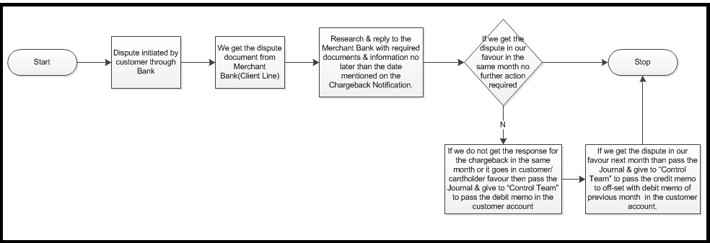

1. Detailed Process Steps

We receive the chargeback dispute from the Merchant website (Paymentech). Based on the reason, we process the documents and submit through the merchant website using the following steps:

* 1. Paymentech Website

1. Login to Paymentech Website

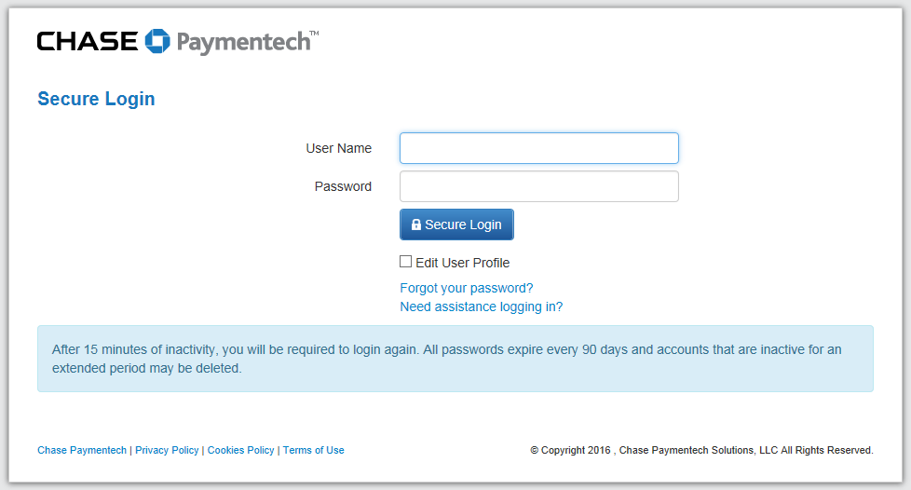

1. Click on the Chargeback Mgmt tab

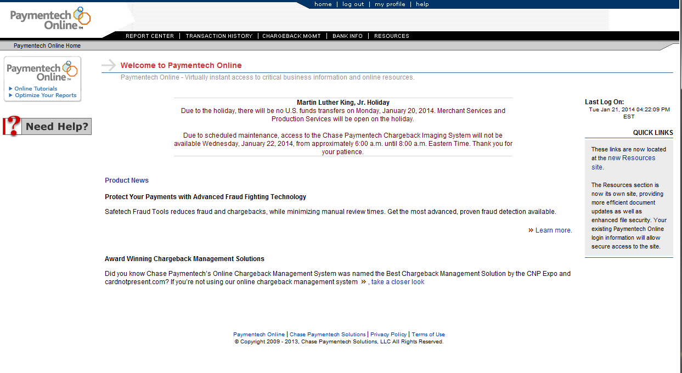

1. Click on My CB Work Queue

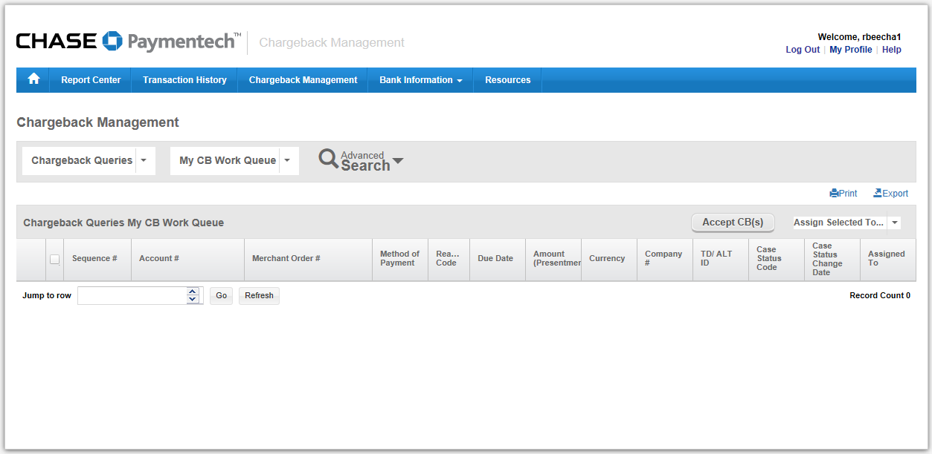

1. Select Aging Details to view the customer chargeback

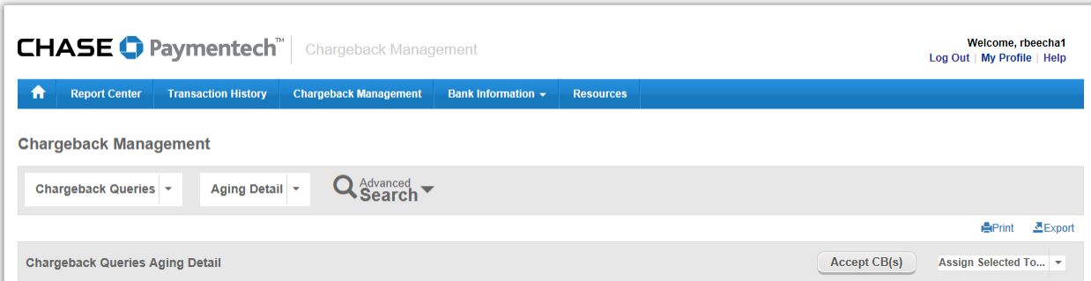

1. Click on the sequence Number to start working on each dispute



1. Review the reason for the dispute to decide the steps that you will follow below
   1. Documentation to Research/Provide Depending on Reason for Dispute

There are multiple reasons that a cardholder may dispute a transaction. The following below sections should be followed depending on the reason. Here are some of the common reasons for disputes and the section that should be followed to provide the correct documentation to Paymentech (these are not all of the reasons so, if it is not listed here, you will need to determine the correct action to take):

1. Credit/Refund not Processed – The cardholder is stating that they are owed a refund by us but did not receive it. You should follow section 4.2.1 Refund Processed / Refund not Owed Documentation.
2. Duplicate Processing – The cardholder is stating they were charged multiple times but should not have been and are owed a refund. You should follow section 4.2.2 Duplicate Processing.
3. Fraud Transaction/No Cardholder Authorization – The cardholder is stating that they did not authorize/participate in the transaction. You should follow sections 4.2.3 and 4.2.4 for online subscriptions and physical product. You should also follow section 4.2.5 if it is a physical product.
4. Services not Rendered/Merchandise not Received – The cardholder is stating they never received the merchandise they ordered. You should follow sections 4.2.3 and 4.2.4 for online subscriptions and physical product. You should also follow section 4.2.5 if it is a physical product.
   * 1. **Refund Processed / Refund not Owed Documentation (Research in Paymentech)**

If a customer is claiming that we did not issue a refund, we will need to look up the transaction history (this can be done in Paymentech or Orbital). The following steps are to look up the transaction history in Paymentech **and should only be done if the cardholder is stating they are owed a refund**:

1. In Paymentech, click on Transaction History
2. Enter the Merchant Order # from the chargeback detail into the Merchant Order # field
3. Click Search

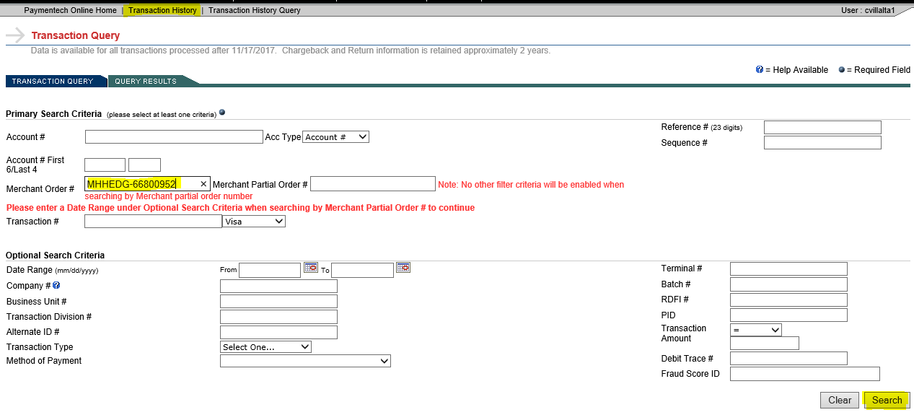

1. **If a refund was processed**, a line will show with RF in the AC field.
   1. If so, click on the line that shows DP in the AC field, then click Address Info. Take a screenshot (like below), so the name and address associated with the transaction is provided and add it to the chargeback documentation. An example of this is in the template section below. The example shows that, although the customer stated we did not give them a refund, we did.

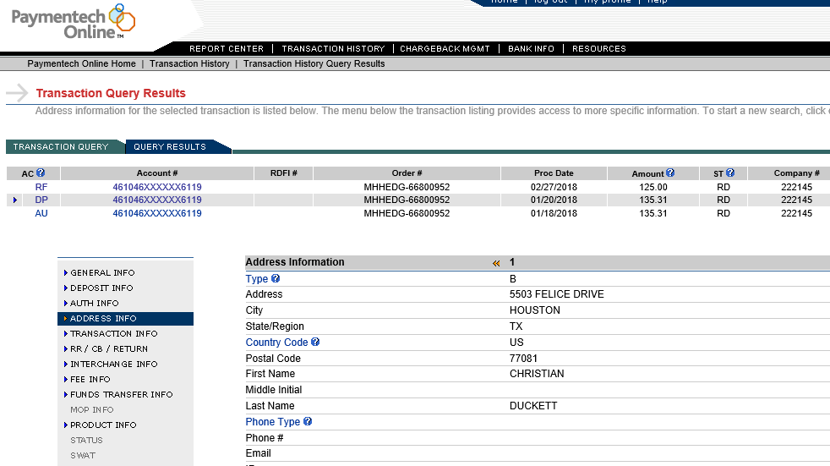

* 1. **Make sure to ALWAYS include the online disclaimer, terms of use, and return policy to the chargeback documentation (included in the attached templates)**

1. **If a refund was not processed**, you will need to research the customer account in Oracle to see if one was requested or is needed. This will require review, but the steps for each possible situation cannot be explained below. You will need to use your judgement and prior experience. Looking up the information in Oracle may be done by reviewing the order in Order Organizer (or Account Details if needed) using the following steps:
   1. In Oracle OTC, go to Order Organizer
   2. Type the order number into the Customer PO field, along with the needed letters before the order number, then click Find
      1. Any Order Number that begins with MHHEDG, type HPIPE then the Order Number
      2. Any Order Number that begins with SEG, type SEGECOM then the Order Number

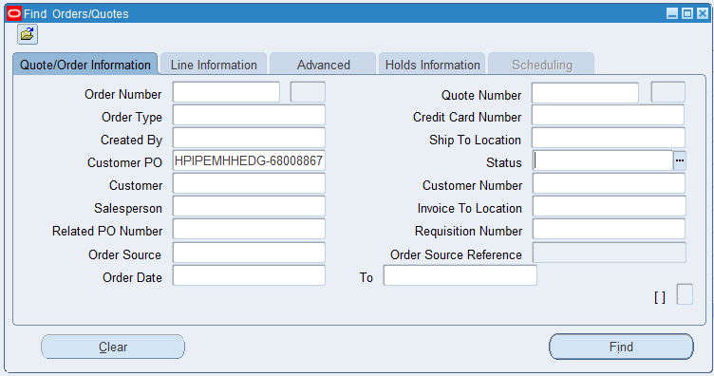

* 1. Find the Customer Number on the order, copy it and click Find to look up the all of the customer’s orders



* 1. Paste the Customer Number in the Customer Number field and click Find
  2. Review all the orders to look for any possible duplicates (by looking at the dates, product names of each order), pending refunds that have not been processed or notes regarding refund requests, or any other notation that a refund is owed or requested.
  3. You can also review the Account Details for the customer to look for any duplicate orders, pending refunds, or refund requests

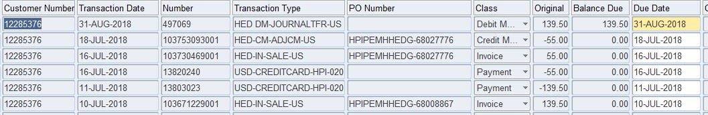

* 1. If you do not find anything in Oracle, the credit card email box should also be checked to see if the customer reached out to us requesting a refund.

1. **If it is found that a refund is owed to the customer,** you have two options:
   1. If you have enough time before the dispute documentation is due, you can process a refund, then dispute the chargeback showing you already refunded the cardholder by doing the following:
      1. Request CSOM to create a credit memo against the invoice that has the chargeback against it. Make sure, if there are multiple invoices/receipts, you request it against the correct invoice.
      2. Once the credit memo is created, process the refund.
      3. Once the refund is processed, you can follow the steps above to dispute the chargeback showing that a refund was processed. This may take up to a week so, make sure there is enough time before the due date.
      4. The debit memo for the chargeback will remain open until we win the case and receive the funds back from the bank.
   2. If you do not have enough time before the dispute documentation is due, do not dispute the chargeback. You should accept the chargeback in Paymentech and do the following:
      1. Request CSOM to create a credit memo against the invoice that has the chargeback against it. Make sure, if there are multiple invoices/receipts, you request it against the correct invoice.
      2. Make sure that you note you do not want to process a refund for this credit memo
      3. Apply the credit memo to the debit memo for the chargeback (which should have a balance due)
2. **If it is found that a refund is not owed to the customer,** dispute the chargeback and provide documentation that states why they aren’t owed a refund, along with the proof of sale documentation (below). An example of this is below in the template section. The example is for a customer that is saying they are owed a refund, but we do not have any record of them requesting a refund from us or any reason why they should receive a refund. Please note: this is only an example. The note at the top may need to be changed for each individual situation, depending on what is found when researching the customer account. You will need to use your judgement.
   1. **Make sure to ALWAYS include the online disclaimer, terms of use, and return policy to the chargeback documentation (included in the attached templates)**
      1. **Duplicate Processing**

If a cardholder raised a chargeback for duplicate processing, we need to research if a refund was given or if they did in fact get charged twice, for the same product.

1. First, check if a refund has been given by following the above steps 4.2.1 (Refund Processed…)
2. If there was, follow the steps above to dispute the chargeback and upload the documentation proving the refund was given
3. If not, you will need to research the customer’s account in Oracle, the same as step 5 in section 4.2.1 above. You should review the account for two charges in the same day. If there are multiple orders, look at the line items of the orders to see the product.
   1. If the product is the same, and it is determined it is a duplicate charge, then the customer is owed a refund and you should follow step 6 of section 4.2.1 above.
   2. If the product is different, and it is determined it is not a duplicate charge, you should dispute the chargeback and follow section 4.2.3 below. Make sure to provide the details of BOTH transactions in Paris, so it shows there were multiple products purchased. Below is a template in the template section for duplicate processing. This is an example where the cardholder did in fact purchase two different products. Please note: this is only an example. The note at the top may need to be changed for each individual situation, depending on what is found when researching the customer account. You will need to use your judgement.
      1. **Proof of Sale Documentation (Research in Safetech)**

If a cardholder is stating they did not authorize/participate in the transaction, the merchandise was not received, or any reason that we may need to provide proof of sale, we will need to provide the documentation for the proof of sale. Since we do not have the cardholder information, we can only provide what we have for the customer’s bank to review. The following steps are to pull the documentation required:

1. Log in to Safetech at https://safetech.chasepaymentech.com/login.html
2. Click on Reports

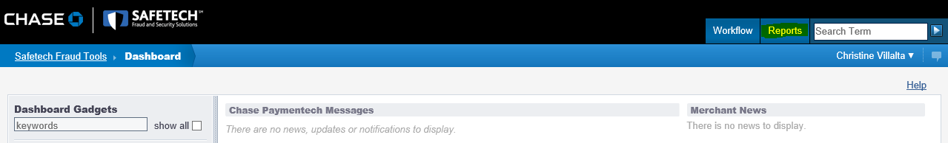

1. Click Order Search
2. In the search criteria on the left, enter the Order # from Paymentech into the Order Number field (usually starts with MHHEDG or SEG)
3. Hit Search

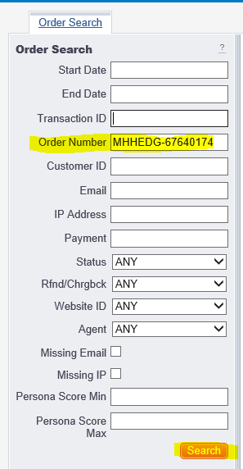

1. Verify the transaction info matches the transaction in Paymentech (to make sure you pulled up the correct transaction)
2. Take a screenshot of the data, from the Transaction Summary section to the User Defined Fields section. Below is an example:

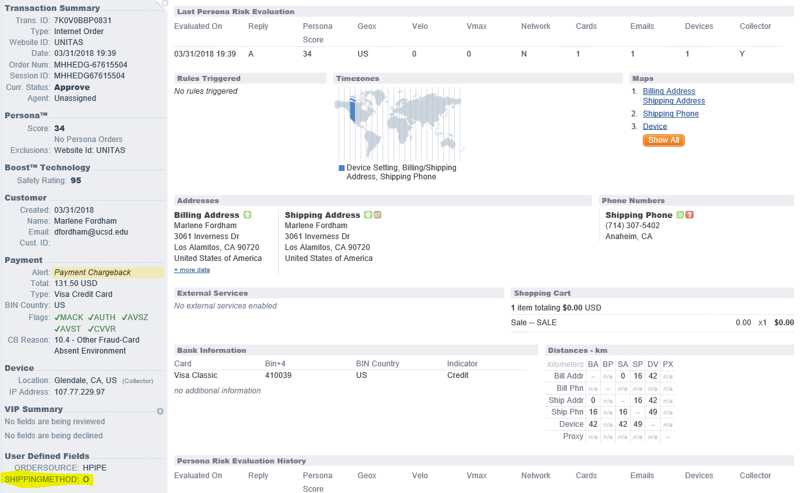

1. One way to determine if the transaction is an online subscription is the shipping method will have an “O” (highlighted in the screenshot above). However, it will not always show an “O” or online subscriptions, so there may be additional research needed in Paris to determine if it is an online subscription or a physical product.
2. Add the screenshot to the chargeback documentation
   1. At this point, if you are not sure if the transaction is for an online subscription or physical product, add the screenshot to a blank word document. When you determine if it is online or physical, you can then make sure you use a previous chargeback template for the proper type (templates are below).
      1. **Proof of Sale Documentation (Research in Paris)**

Since Safetech does not provide the product information, Paris is used to pull the product information, along with the subscription information, if applicable.

1. Log in to Paris at <https://paris.mheducation.com/parisAdminTool/login.html> (it is recommended to use Chrome rather than Internet Explorer since some information may not be visible in IE)
2. Click New Purchase Audit Tool

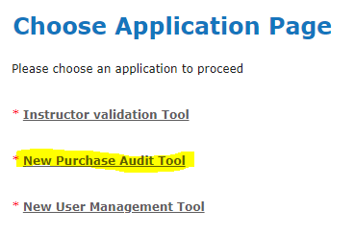

1. Change the Search Column Name to Order Number
2. Type the Order Number into the Search Value field and click Search

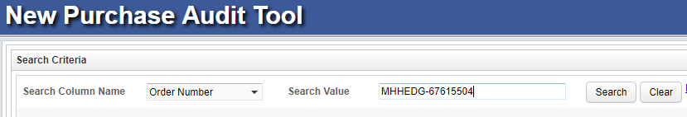

1. Take a screenshot of the order information, along with the headers (as shown below), and add it to the chargeback documentation

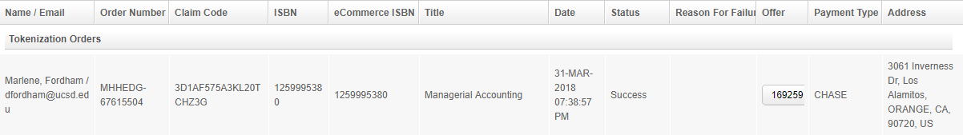

1. Click Back
2. Click New User Management Tool

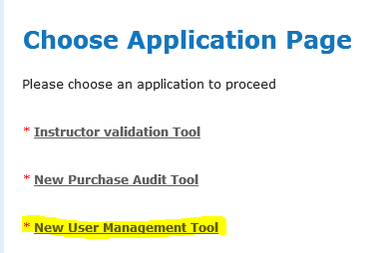

1. Type the email address (found on the previous screenshot and in Safetech) into the search field and click Search
2. Click on the License tab

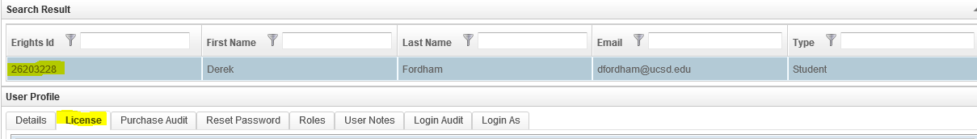

* 1. There may be multiple subscriptions listed. Only take a screenshot of the transaction in question, which will be matched by the ISBN and Start Date to the same from the Purchase Audit screen.

1. Take a screenshot of the transaction, along with the headers (as shown below), and add it to the chargeback documentation:

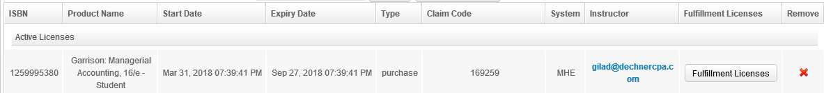

1. Not all the information in the example above will show for every transaction. Some online subscriptions do not provide all the information. So, it may be difficult to determine if the transaction is for an online subscription or a physical product.
   1. If there is a Start and Expiry Date, it is for an online subscription and you do not need to follow section 4.2.4.
   2. If there is an “O” for the shipping method in Safetech (as explained above), it is for an online subscription and you do not need to follow section 4.2.4.
   3. If any of the above are blank, follow section 4.2.4 to determine if the transaction is for a physical product and, if so, provide the proof of delivery.
   4. If the email does not come up with any information, follow section 4.2.4 to get the product information from Oracle.
2. **Make sure to ALWAYS include the online disclaimer, terms of use, and return policy to the chargeback documentation (included in the attached templates)**
   * 1. **Proof of Sale/Delivery (Research in Oracle OTC)**

If the transaction is for a physical product, as stated above in the Paris section, we will need to provide proof of delivery. This is obtained through Oracle as follows:

1. Log in to OTC
2. Choose View Order Organizer

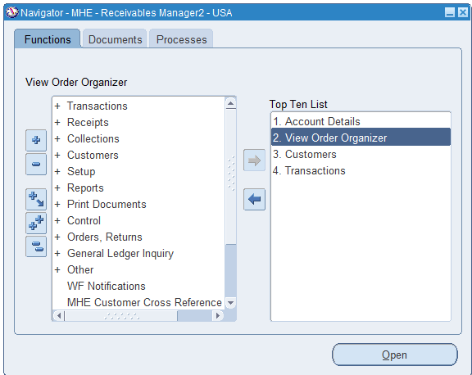

1. Type the order number into the Customer PO field, along with the needed letters before the order number, then click Find
   1. Any Order Number that begins with MHHEDG, type HPIPE then the Order Number
   2. Any Order Number that begins with SEG, type SEGECOM then the Order Number

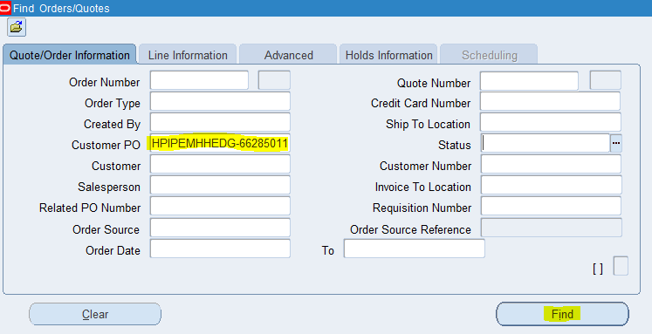

1. Click on the line and hit Open
   1. If there are multiple lines, there may be multiple proof of deliveries. Make sure to check each line.
2. **Only if you were not able to pull up the product information in Paris with the email address,** follow these steps. If you were able to pull up the product information in Paris, skip to number 6.
   1. Click the Line Items tab
   2. Take a screenshot of the information (as shown below) and add it to the chargeback documentation

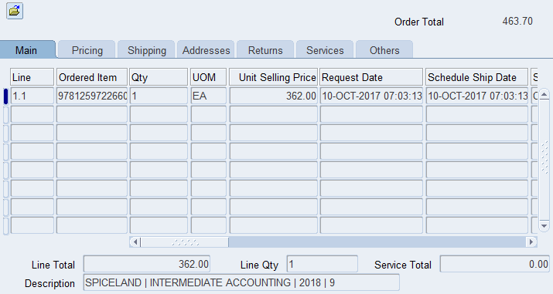

* 1. Close the screen and repeat only if there are multiple lines for the order

1. For Proof of Delivery, click Reports, MHE Shipment Tracking

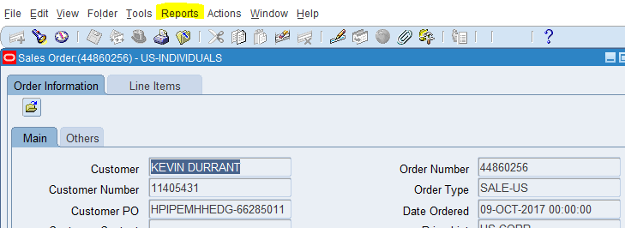

1. The tracking information will pull up in a new tab on your browser

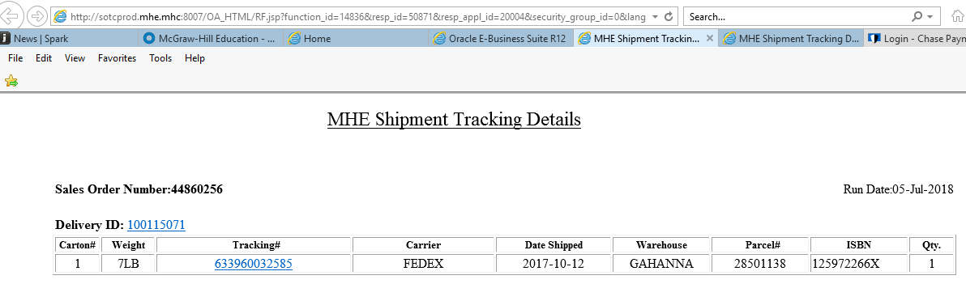

1. If the screen pulls up and says, “No Data”, this means it is not for a physical product and you do not have to continue following the steps.
2. If there is tracking details, click on the Tracking #
3. Click on Obtain Proof of Delivery

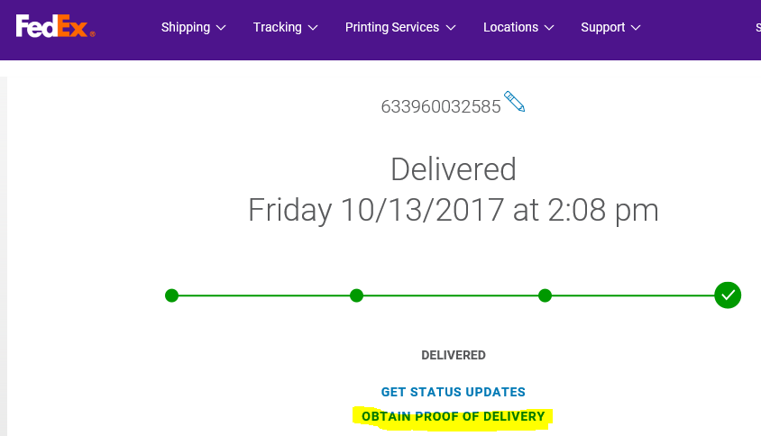

1. Click Submit
2. Click Open when it asks
3. Take a screenshot of the proof of delivery and add it to the chargeback documentation

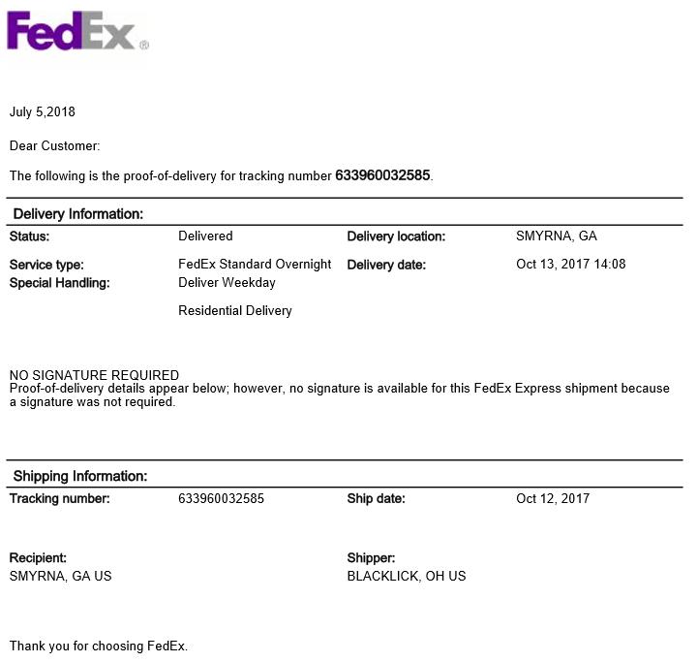

1. **Make sure to ALWAYS include the online disclaimer, terms of use, and return policy to the chargeback documentation (included in the attached templates)**
   1. Accepting Chargebacks

Occasionally, we will need to accept a chargeback rather that dispute it. We should try to avoid this by taking the proper steps in a timely manner, since accepting too many chargebacks can have a negative effect on our business, along with additional fees. The following are a couple of possible reasons we will need to accept a chargeback, although they may not be the only reasons.

1. Duplicate Processing or Credit (Refund) not Processed – if after researching, per the steps above, it is found the cardholder is owed a refund, we should first see if there is enough time to refund the cardholder.
   1. If you have enough time before the dispute documentation is due, you can process a refund, then dispute the chargeback showing you already refunded the cardholder by doing the following:
      1. Request CSOM to create a credit memo against the invoice that has the chargeback against it. Make sure, if there are multiple invoices/receipts, you request it against the correct invoice.
      2. Once the credit memo is created, process the refund.
      3. Once the refund is processed, you can follow the steps above to dispute the chargeback showing that a refund was processed. This may take up to a week so, make sure there is enough time before the due date.
      4. The debit memo for the chargeback will remain open until we win the case and receive the funds back from the bank.
   2. If you do not have enough time before the dispute documentation is due, do not dispute the chargeback. You should accept the chargeback in Paymentech and do the following:
      1. Request CSOM to create a credit memo against the invoice that has the chargeback against it. Make sure, if there are multiple invoices/receipts, you request it against the correct invoice.
      2. Make sure that you note you do not want to process a refund for this credit memo
      3. Apply the credit memo to the debit memo for the chargeback (which should have a balance due)
2. Fraud Transactions – If it is found that the chargeback was in fact a fraudulent transaction, we should first see if there is enough time to refund the cardholder. We usually find out about fraud by Andi Kraft and his team.
   1. If you have enough time before the dispute documentation is due, you can process a refund, then dispute the chargeback showing you already refunded the cardholder by doing the following:
      1. Since it is known fraud, we are NOT going to request a credit memo from CSOM.
      2. Go into the customer’s account in Oracle and unapply the receipt
      3. Process a refund through Oracle
      4. Write the invoice off to Fraud
      5. Once the refund is processed, you can follow the steps above to dispute the chargeback showing that a refund was processed. This may take up to a week so, make sure there is enough time before the due date.
      6. The debit memo for the chargeback will remain open until we win the case and receive the funds back from the bank.
   2. If you do not have enough time before the dispute documentation is due, do not dispute the chargeback. You should accept the chargeback in Paymentech and do the following:
      1. Since it is known fraud, we are NOT going to request a credit memo from CSOM.
      2. Write the debit memo that is open for the chargeback off to Fraud

* 1. Templates (Refund Processed, Refund not Owed, Online & Physical Product)

Attached are four different templates to follow for the documentation to upload to Paymentech for the dispute. Please set the top and bottom margins to .50, the left and right margins to .25, and expand the screenshots to the end of the margins so they are easier to read. **Make sure to ALWAYS include the online disclaimer, terms of use, and return policy on all documentation submitted. All the below templates include these.**

    

* 1. Uploading Documentation to Paymentech

1. After completing the documentation, submit it in Paymentech. The steps to look up the chargeback are above if needed.
2. Click on Available Actions

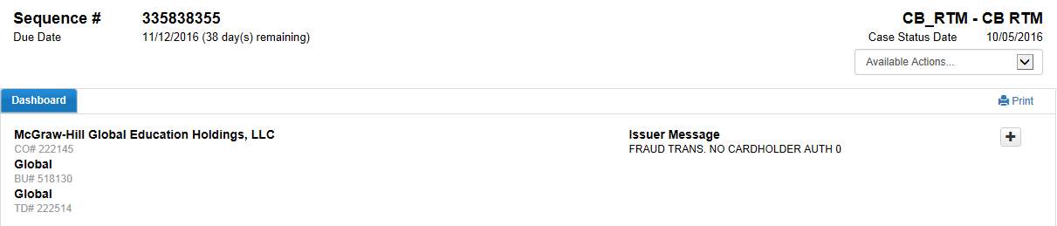

1. From Available Actions drop down, select the Challenge Item to upload the documents into the Merchant Website.

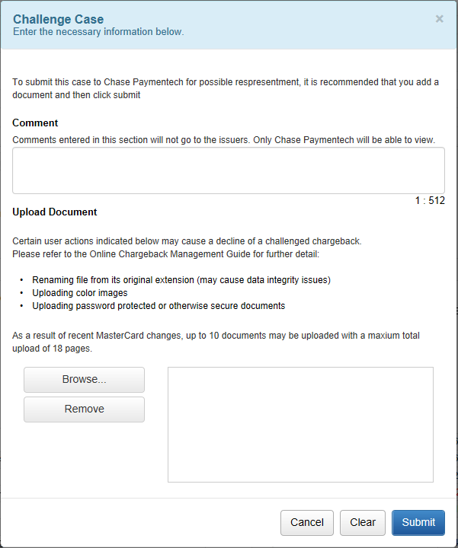

1. Select browse and upload the dispute documentation
2. Click Submit Case
3. Process Exceptions Handling
4. Compliance control

Although this document depicts the pictures of MHE Oracle the process is the same for both HPI and SEG. This SOP covers all disputes for bankcard regardless of the Company.

Genpact is required to complete the necessary documentation and file the paperwork for all disputes by the date required by the bank. They must continually follow up on the open case until it is resolved by the bank.

1. Escalation process

First Level of Escalation:

Offshore-Genpact Manager-Bhavsar Parth-[Parth.Bhavsar@mheducation.com](mailto:Parth.Bhavsar@mheducation.com)

Second Level of Escalation:

Onshore-Director, AR Operations-Luckie Kathy-[kathy.luckie@mheducation.com](mailto:kathy.luckie@mheducation.com)

1. Process SLAs
2. Related Documents
3. FAQ
4. Sign Off

ss

Kathleen Luckie 10/29/2020